Promote your participation and encourage your customers to join you at IFMA’s Facility Fusion this year. Follow these 3 simple steps below to share on your social media channels (LinkedIn, Facebook, Instagram or X):

Looking for additional marketing resources (i.e. logos, banners, etc.)? Access the full Event Marketing Toolkit.
Download the exhibitor social cards and chose the image version that best fits the social media channel you are posting on: Social Cards_Exhibitor Add the photo to your post.
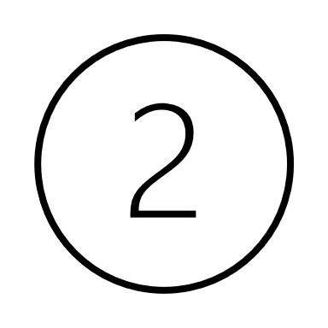
Use sample template(s) below for your post (feel free to customize):

Template #1
🌟 Exciting News! [Exhibitor Name] is thrilled to be part of IFMA’s Facility Fusion® Conference and Expo in Boston, Massachusetts. 🏢✨ Join us at Booth [Your Booth Number] to explore innovative solutions for [mention specific industry/facility challenges].
🤝 Connect with industry leaders, showcase your products/services, and stay at the forefront of facility management trends. Don't miss out on this prime opportunity to network and elevate your business!
🗓️ Expo Date: May 6, 2024
📍 Location: Boston, Massachusetts
🔗 Learn more and register: https://facilityfusion.ifma.org/
#FacilityFusion #Exhibitor #Innovation #FacilityManagement #Conference #Networking
Feel free to customize it with specific details about your exhibitor's offerings and booth information.

OR

Template #2
🌟 Exciting News! We're thrilled to announce that <Exhibiting Company Name> will be showcasing at IFMA’s Facility Fusion® Conference and Expo on May 6, 2024 in Boston, Massachusetts! 🏢✨ Explore cutting-edge FM solutions and get hands-on access to the latest products and services. Swing by our booth to discover:
1️⃣ [First compelling reason]
2️⃣ [Second compelling reason]
3️⃣ [Third compelling reason]
Don't miss out on this opportunity to enhance your facility management journey!
🗓️ Save your spot: https://facilityfusion.ifma.org/
#FacilityFusion #FacilityManagement #FM #Conference #Expo #BuiltEnvironment
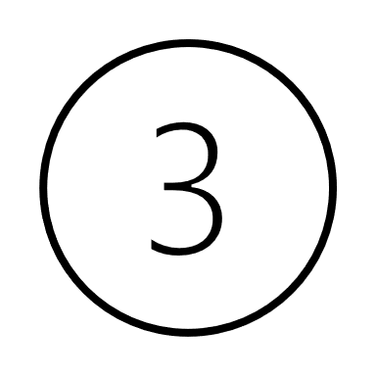
Tag IFMA so we can share your post as well! Then click on ‘Post’.

#facilityfusion
LinkedIn & Twitter: @IFMA
Facebook: @InternationalFacilityManagementAssociation
Instagram: @ifma_hq

